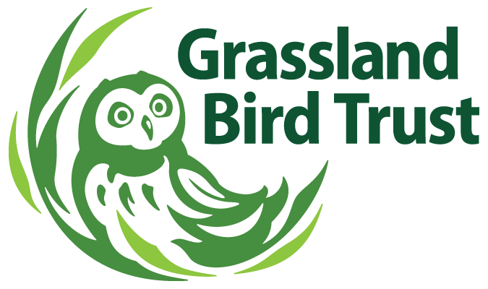

Grassland Bird Trust, Inc.
www.grasslandbirdtrust.org

Field Trip Participant Info & Liability Release

TRIP: _______________________ TRIP DATE(s): __________________
Participant Name: ____________________________________________
Address: ___________________________________________________
____________________________________________ Zip Code: __________
Phone: _________________________ Email: ______________________________
Emergency Contact (Name): _______________________________________
(Address): ______________________________________________________
________________________________ (Phone): ____________________________
RELEASE OF LIABILITY

By signing below, I acknowledge that the activities associated with this trip to be conducted by Grassland Bird Trust may involve the risk of personal injuries or death.

I hereby agree for myself, all my family members and heirs, to be effective to the greatest extent permitted by law, to release Grassland Bird Trust, Inc. and any of their employees, officers, directors, members, trip leaders or agents from any and all liability claims, losses, and/or damages for personal injuries or death which may occur during participation in the above-named trip and outdoor recreation activities associated with said trip.

I hereby agree for myself, all my family members and heirs, to be effective to the greatest extent permitted by law, not to sue or make any negligence claim against to release Grassland Bird Trust. and any of their agents, employees, officers, instructors, guides, directors, trip leaders, governors, and members for personal injuries or wrongful death suffered as a result of participation in the above-named trip or activity and the alleged negligence of any of the parties described above.

I intend this release and agreement not to sue to be effective whether or not the injury or death results, in whole or in part, from the negligence of Grassland Bird Trust their agents, employees, officers, instructors, guides, directors, trip leaders, governors and/or members.

I understand that negligence means failure to do an act, which a reasonable and careful person would do, or the doing of an act, which a reasonably careful person would not do, under the same circumstances, to protect another from injury or death. I agree to be solely responsible for my own safety and to take every precaution to provide for my own safety and well-being while participating in the trip and outdoor recreational activities listed above.

I knowingly assume the following risks, which include but are not limited to, the risk of personal injury or death, which may occur during participation in the above-named trip and the outdoor recreation or activities associated with said trip, including the potential negligence of the trip leader(s).

I also agree to release Grassland Bird Trust from any and all liability for exposure to the Coronavirus (COVID-19) during the Field Trip and any resulting illness or harm.

Signature: __________________________________________________(legal guardian sign for minors)
OFFICE USE ONLY: Date Received: ____________________ Date Processed: ______________________

